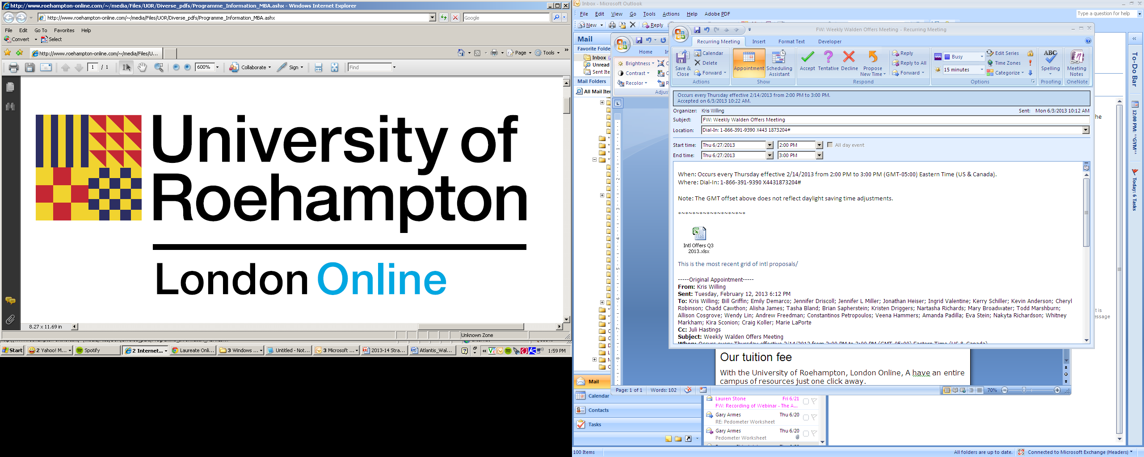

Online Master’s Degrees

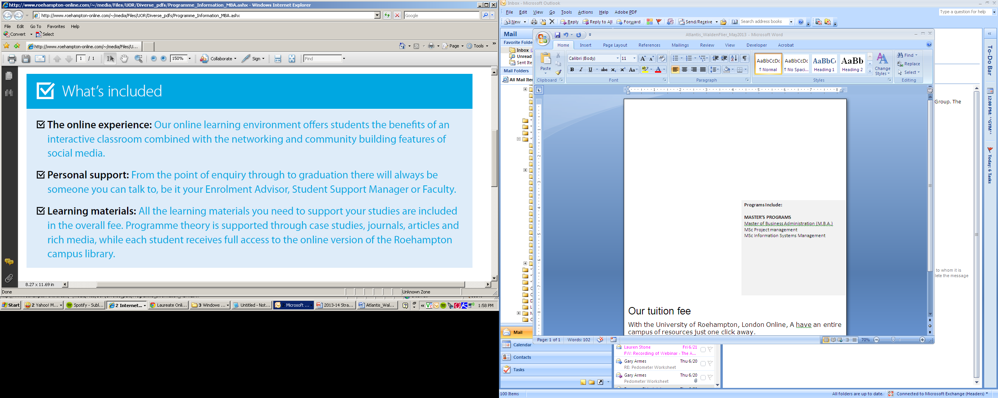

**Inspiring you to discover what’s next**

With the University of Roehampton, London Online,   
 **YOU** have an entire campus of  
 resources just one click away.

MASTER’S PROGRAMMES

* Master of Business Administration (M.B.A.)
* MSc Project Management
* MSc Supply Chain Management
* MSc Information Systems Management
* MSc Strategic Human Resource Management



OUR TUITION FEE

Our tuition fee of $10,000 for all masters programmes covers everything you'll need to succeed as an online student. Our straightforward payment plan facilitates regular, manageable payments.

**For more information:**

* Call Kelly Bute-Seaton at **876-461-7558**
* Or Email Kelly Bute-Seaton at[**Kelly.Bute-Seaton@laureate.net**](mailto:Kelly.Bute-Seaton@laureate.net)