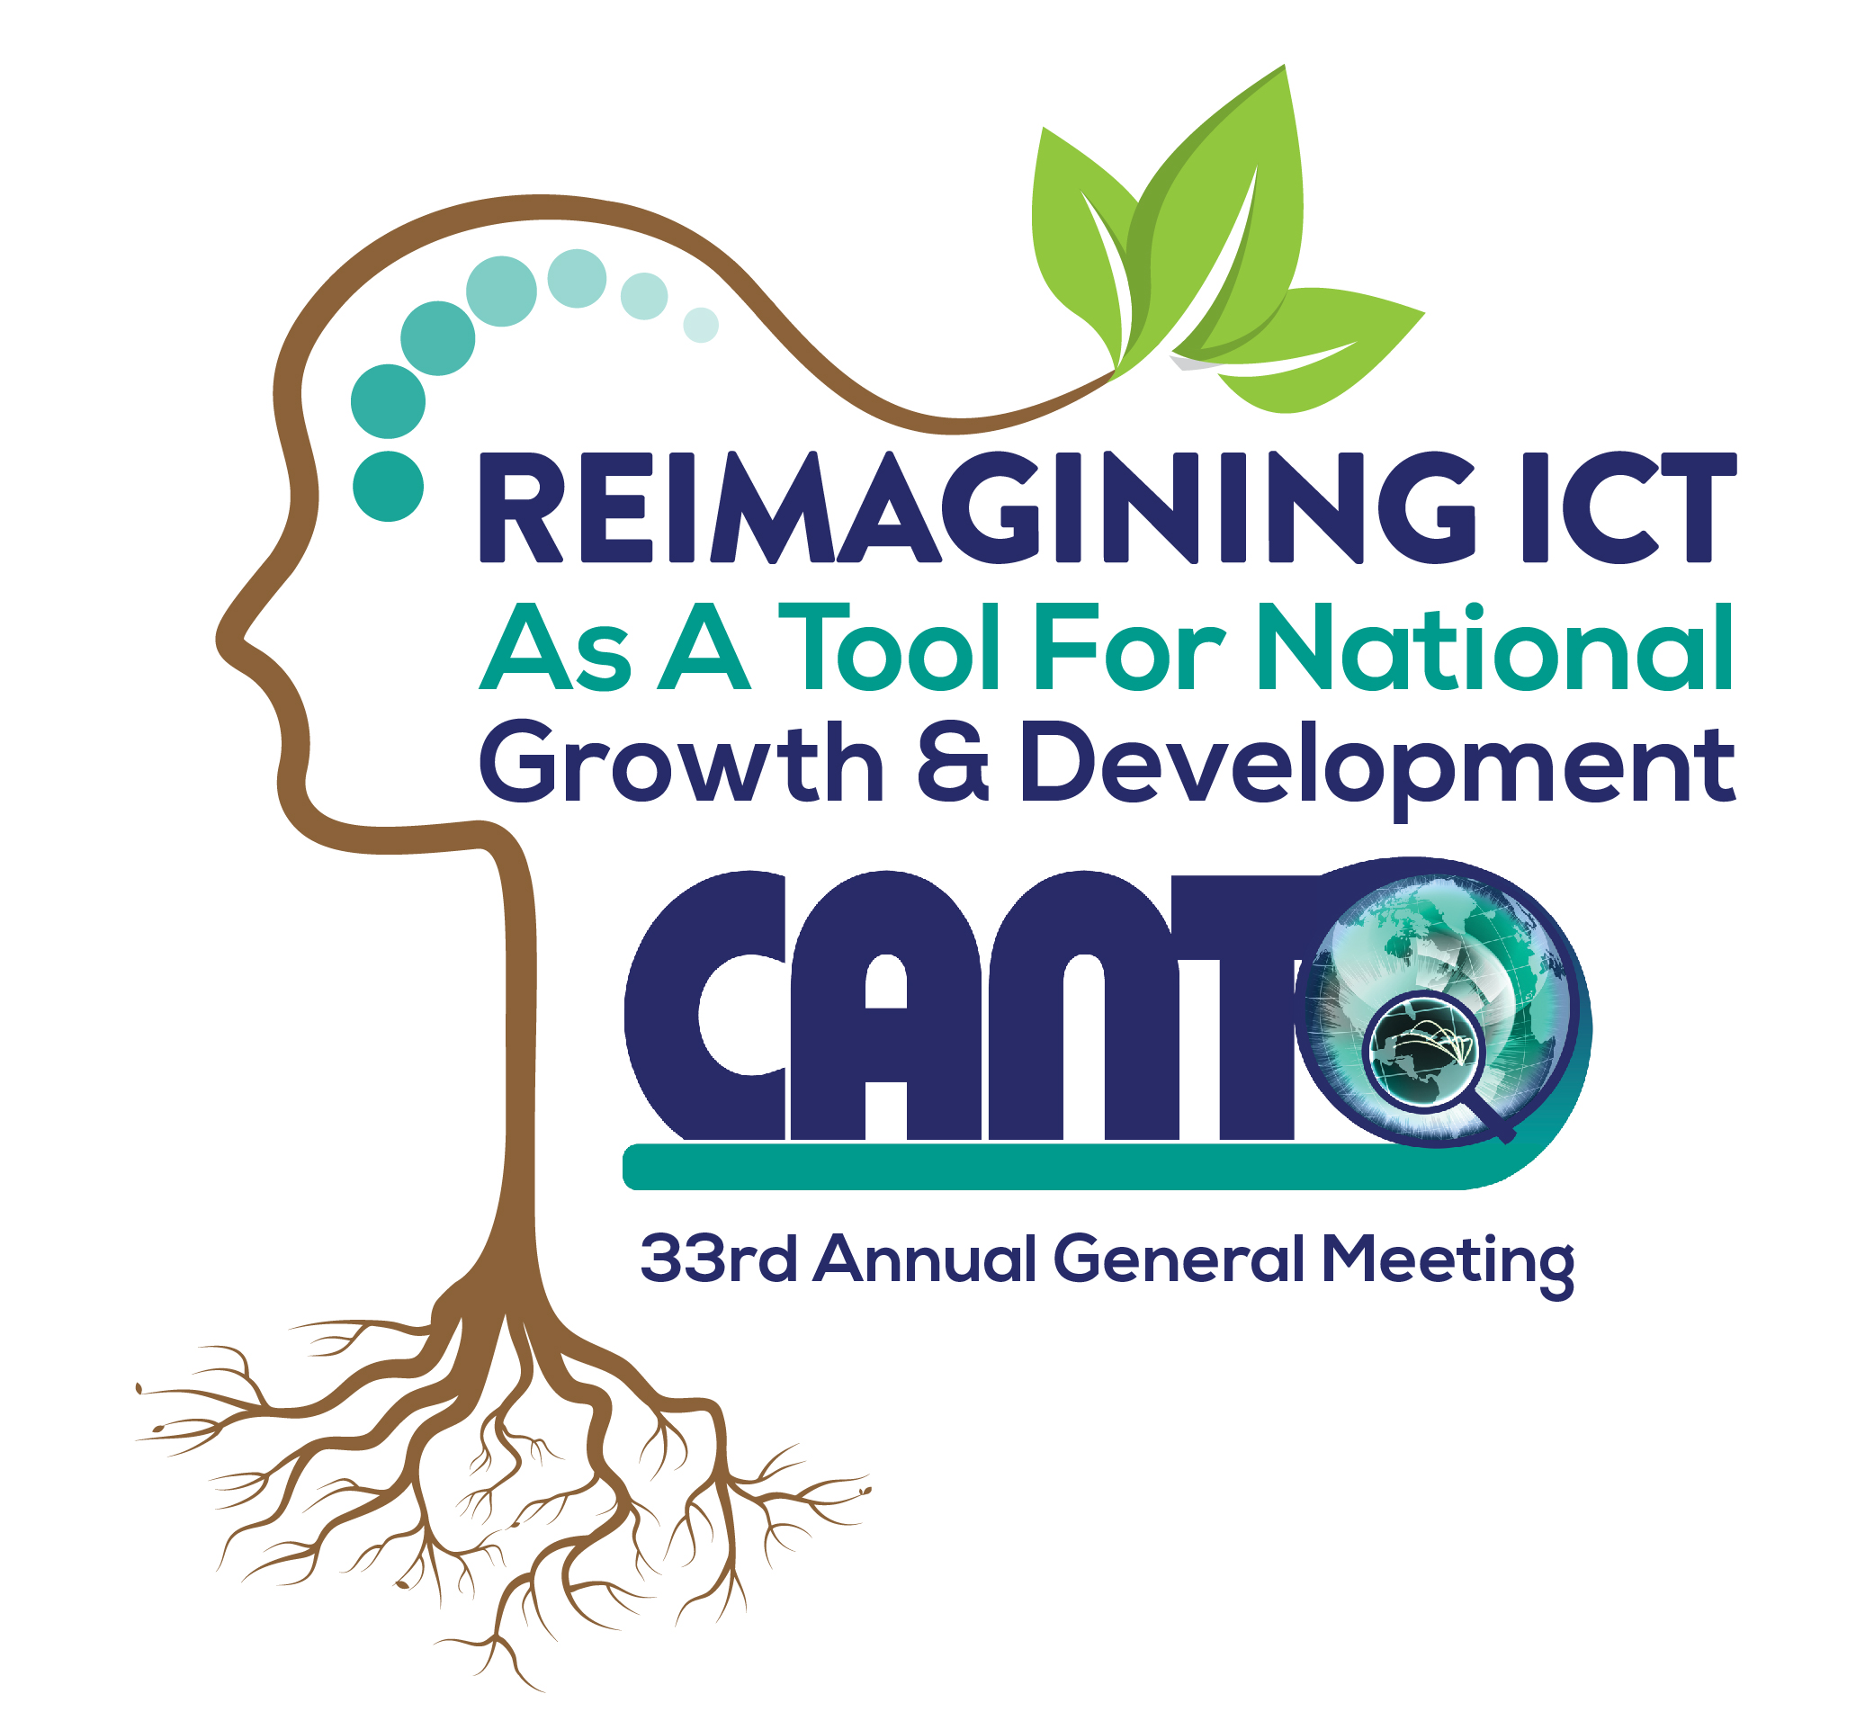

SPONSORSHIP OPPORTUNITIES

EVENT/ITEM | AMOUNT ($US) | Entitlements
Gold | $10,000 | - 20 minute presentation at AGM  - Full page color Ad. in the Annual Report  or 1st /2nd quarter of the 2017 Cancion  - One (1) booth (table)  - Company logo displayed on (2) individual banners  - Company logo displayed on event, key sponsors’ banner and website/social media  - Public announcements throughout AGM  - On Screen Rotary Ad (full page)
Silver | $5,000 | - 10 minute presentation at AGM  - ½ page color Ad. in the Annual Report  - Company logo displayed on (1) individual banner Company logo displayed on key sponsors’ banner  - Company logo displayed on event, key banners and website/social media  - Public announcements throughout AGM  - On Screen Rotary Ad (full page)
Bronze | $3,000 | - 5 minute presentation at AGM  - Company logo displayed on key sponsors’ banner  - Company logo displayed on event banner and website/social media  - Public announcements throughout AGM  - On Screen Rotary Ad (full page)
Bags | $5,000 | - Logo on bag  - Company logo displayed on event banner and website/social media sites  - Public announcements throughout AGM  - On Screen Rotary Ad (logo page)
Lunch (2) | $5,000 | - 10 minute presentation at sponsored lunch  - Company logo visibly displayed on event banner and webpage  - Public announcements at sponsored lunch  - On Screen Rotary Ad (logo page)
Polo Shirts | $5,000 | - Logo on Shirts  - Company logo displayed on event banner and website/social media sites  - Public announcements throughout AGM  - On Screen Rotary Ad (logo)
Coffee Breaks (4) | $2,500(per break) | - ‘Sponsored by’ table tents  - Company logo displayed on event banner and webpage/ social media sites  - Public announcements at the sponsored coffee break  - On Screen Rotary Ad (logo)
Cocktail/Dinner | $10,000 | - Full page Ad. In Annual Report  - ‘Sponsored by’ table tents  - Company logo visibly displayed on event banner and webpage/ social media sites  - Public announcements at sponsored lunch  - Company logo displayed on event banner and webpage  - On Screen Rotary Ad (logo)
Closing Dinner | $10,000 | - Full page Ad. in Annual Report  - Sponsored by table tents  - Company logo displayed on event banner and webpage  - Public announcements at sponsored event  - On Screen Rotary Ad (full page )
CANTO Annual Report | $3,000 | - Full back page Ad. in the Annual Report  - Company logo displayed on event banner and website/social media sites  - Public announcements at AGM  - On Screen Rotary Ad (logo)
Banners x 2 Registration Area | $2,500 | - Company logo displayed on event banner and website/social media sites  - Public announcements at AGM  - On Screen Rotary Ad (logo)
Banners x 1- AGM Hall | $1,000
Pens/Notepads/Napkins (Sponsor provides) | $500
Flyer distribution in AGM bag | $250
Screen Savers  - Opening Ceremony  - AGM Proceedings | $1,000  $500
Advertisement on event website | $500
Contact:
Carmen Ramlal/Tricia Balthazar
Email:cramlal@canto.org; tbalthazar@canto.org;
Phone: (868) – 622-3770/4781/0929
Fax: (868) 622-3751
Website– http://canto.org/events-conferences/annual-general-meeting-agm/

