 | CANTO 29th Conference & Trade Show Exhibition  14th -17th July 2013,  Renaissance Aruba Resort & Casino  Aruba
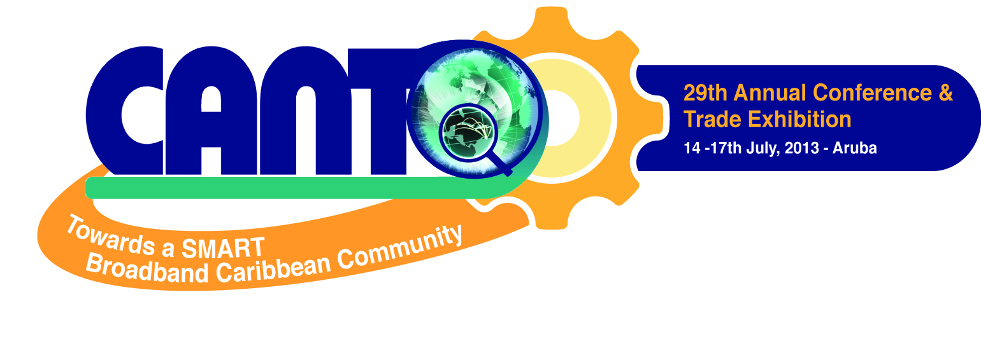 | 

 | 7th Annual Human Resource Forum  18th -19th July 2013,  Renaissance Aruba Resort & Casino  Aruba

 | LACNIC in the Caribbean 5    17th – 19th July 2013,  Renaissance Aruba Resort & Casino

Saturday 13 July 2013

Closed Session: CANTO BOARD OF DIRECTORS MEETING

10:00 am – 4:00 pm
Board Room, Marina Hotel

Closed Session: CANTO BOARD OF DIRECTORS NETWORKING DINNER

7:00 pm – 10:00 pm

Sunday 14 July 2013

CANTO COMMITTEE MEETINGS

9:00 am -10:45 am  Convention Centre Mtg Rm  Convention Centre Mtg Rm  LG Smith Private Room  Board Room, Marina Hotel  Board Room, Marina Hotel | CANTO Committee Meetings  Marketing and Communications Committee Meeting - 9:00 am  Regulations and Emerging Technologies Committee Meeting - 10:00 am  Financial Advisory Committee Meeting – 10:00 am  Disaster Preparedness Committee Meeting – 11:00 am  Human Resource Committee Meeting - 10:00 am

COMMITTEE CHAIRS PRESENTATION TO CANO BOARD

12:00 – 2:00 pm  Board Room, Marina Hotel | Marketing and Communications Committee Meeting  Regulations and Emerging Technologies Committee Meeting  Human Resource Committee Meeting  Disaster Preparedness Committee Meeting

BIIPAC STEERING COMMITTEE MEETING

2:00 – 4:00 pm  Convention Centre Mtg. Room | Dialogue on the Broadband Infrastructure, Inventory & Public Awareness In The Caribbean Project

PRESS CONFERENCE

4:00 – 4:45 pm

OFFICIAL OPENING CEREMONY OF CANTO 2013

5:00 – 8:00 pm  Crystal Theatre  Marina Hotel | Government Ministers, CANTO Executives, and Members, Officials of Aruba and other dignitaries in attendance
 | RIBBON CUTTING, EXHIBITION VIEWING AND COCKTAIL RECEPTION

Monday 15 July 2013

LIME SPONSORED Ministerial Breakfast Briefing

7:00 – 8:30 am
Convention Centre Mtg. Room

Ministerial Roundtable: Towards a SMART Broadband Caribbean

9:00 -10:45 am  Convention Centre Mtg. Room | Moderatos: Dirk Currie, CANTO Chair & Karen Bevans, CANTO Vice Chair  This Roundtable will discuss how the region can develop Broadband Plans that combine strategies and programs to foster GDP growth, create jobs and stimulate innovation  - MBB and its benefits for the operators, society and governments - Lourenco Coelho, Ericsson  - Hon. Evan Gumbs, Min of Infrastructure, Com, Utilities, Anguilla  - Hon. Joy Grant Min of Pub Utilities, Information & Broadcasting, Belize  - Min of Communications, Works, Physical Development, Public Utilities & ICT, Grenada  - Hon. Darcy Boyce, Min of State Responsible for Telecom, Barbados  - Hon Charles Kirnon, Minister of Communications & Works, Montserrat  - Hon James Fletcher, Min of Public Services, Sustainable Development, St. Lucia
10:45 – 11:00 am | COFFEE: SPONSORED BY ATLANTIC TELE NETWORKS INTERNATIONAL

Ministerial Roundtable: Towards a SMART Broadband Caribbean

11:00 am – 1:00 pm  Convention Centre Mtg. Room | Moderatos: Dirk Currie, CANTO Chair & Karen Bevans, CANTO Vice Chair  This Roundtable will discuss how the region can develop Broadband Plans that combine strategies and programs to foster GDP growth, create jobs and stimulate innovation  - Dr. Jerrol Thompson, Director of Special Projects In Telecom, St. Vincent & the Grenadines  - Hon. Falisie Pinas, Min. of Transport, Com & Tourism, Suriname  - Hon. Mark Vanterpool, Ministry of Communications & Works, Tortola  - Hon. George Lightbourne, Minister of Government Support Services, Turks and Caicos  - Hon. Vance Amory, Minister of Telecoms, Nevis
1:00 – 5:00 | LUNCH & EXHIBITION VIEWING

Delivery of innovative and integrative public sector ICT solutions and services
2:00 – 3:30 pm  Convention Centre Mtg. Room | iGovTT

5:00 – 6:00 pm | ARIN Private Cocktails

7:00 – 10:00 pm | CANTO ERICSSON DINNER AND iCREATE Awards Ceremony
Tuesday 16 July 2013

WOMENS BREAKFAST SPONSORED BY LACNIC

7:00 – 8:30 am
Convention Centre Mtg. Room

Track 1: Mobile Networks, Broadband Capacity and the Regulatory Paradigm Shift
9:00 -10:45 am  Convention Centre Mtg. Room | Chair: Melesia Sutherland-Campbell, CANTO Member  This track will address how service providers must adapt as the pace of demand for broadband capacity is increasing dramatically as customers’ appetite for mobile devices, bring your own device technology (BYOD), video content and enterprise cloud adoption increases  - Broadband incentives’ impact the rollout of broadband in Belize – Rafael Marin, Belize Telemedia  - ITR and its impact on Caribbean Operators: Cleveland Thomas, ITU Caribbean Representative  - The Role of LTE in M2M - Charles Alexi, TONEX  - Opportunities from a combined FTTx rollout - Niels Gabriels, Comsof NV
10:45 – 11:00 am | COFFEE

Track 2: Migrating to the Cloud – Security up High
11:00 am – 1:00 pm  Convention Centre Mtg. Room | Chair: Davidson Charles, CANTO Director  This track will address evolving standards, technologies, policies and market potential for cloud solutions, architectures and best practices  Topics:  - Nir Zuk – Palo Alto Networks  - Choose Cloud, Abandon the Box - Kevin Mitchell, Alianza  - Leveraging Cloud-Computing for Generation of Capacity - Yair Shapira DiViNetworks  - The importance of Data Centres
1:00 – 5:00 | LUNCH & EXHIBITION VIEWING

BIIPAC Steering Committee Meeting for IDB Members
11:00 am – 1:00 pm  Convention Centre Mtg. Room | This forum will focus on the Broadband Infrastructure Inventory and Public Awareness Project in the Caribbean
10:45 – 11:00 am | COFFEE

Track 3: Connect the Caribbean
2:00 pm – 4:00 pm  Convention Centre Mtg. Room | This forum will focus on the work of international and their impact on Connect the Caribbean  Chair: E Jay Saunders, CANTO Director  - ISOC at Your Service: Sheron Osepa, Internet Society  - Raul Echeberría, LACNIC  - IPv6 – what’s in your transition plan - ARIN  - ITU – Connect the Caribbean Agenda - Cleaveland Thomas, ITU Caribbean Representative

Wednesday 17 July 2013

Track 4: Smart Connectivity: Smart Partnerships
9:00 -10:45 am  Convention Centre Mtg. Room | Chair: Julian Wilkins, CANTO Director  This track will look at how the right partnerships with key players can help telcos leverage existing network infrastructure, large customer base, distribution channels and solution providers to increase revenues  Topics:  - Keynote: Monetizing LTE – How LTE help to increase ARPU and become even more profitable - Jose Villalobos, Ericsson  - Leveraging mobile roaming data to boost revenues – Mike Erickson Tektronix Communications  - Reducing Cost - Mobile Termination Rates Across the Region – LIME  - mobile payment and mobile money  - Video and content
10:45 – 11:00 am | COFFEE

Track 5: Network Automation and Big Data equals Big Opportunities
11:00 am – 1:00 pm  Convention Centre Mtg. Room | Chair: Lawrence Mc Naughton, CANTO Director  This track will explore how providers can increase revenue by offering solutions that provides customers with better access to information with content delivery networks  - Keynote: Optimizing mobile networks – WiFi offloading and the HetNet concept - Fabio Rodriguez, Ericsson  - Building the Next Generation Mobile Network –Vince Spinelli, Juniper Networks.  - Affordable Broadband in the Caribbean - Stephen Yablonski, Globecomm  - 4G Technologies: Myths vs. Reality - Leonhard Korowajczuk, CelPlan Technologies
1:00 – 5:00 | LUNCH & EXHIBITION VIEWING

Sponsored session:
1:00 – 3:00 pm
Convention Centre Mtg. Room

Closing
7:00 – 9:00 pm | Regenie Fraser, Secretary General, CANTO  - Announcements  - Announcement and Invitation to 2013 AGM co hosted by LIME, Jamaica – Lawrence Mc Naughton, CANTO Director  - Announcement and Invitation to CANTO 2014 co hosted by Digicel Turks & Caicos – Ejay Saunders, CANTO Director


#67 Picton Street, Newtown
Port of Spain,
Trinidad & Tobago
Telephone: 1 868 622 4781/
Fax: 1 868 622 3751
www.canto.org

DRIVING PERFORMANCE THROUGH INNOVATIVE LEADERSHIP
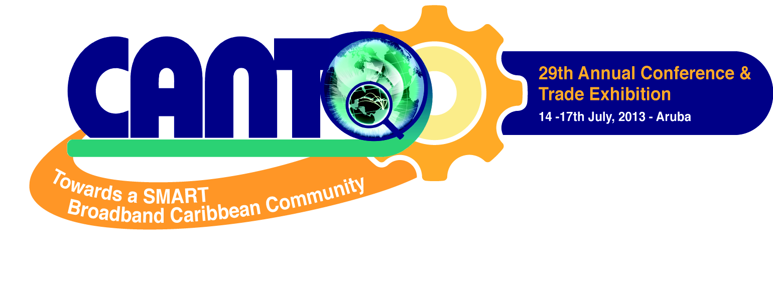

FEATURE SPEAKER: Dr. Earl Suttle
FACILITATOR: Ian Blanchard

7TH ANNUAL HUMAN RESOURCE FORUM 2013
Driving Performance Through Innovative Leadership

Co – Hosted by SETAR
BRIEF DESCRIPTION:
The HR forum takes place immediately after the 29th Annual Conference and Trade Show Exhibit in Aruba. Participants will benefit from the HR and Training expertise of world class speakers from around the region and globally. This dynamic two-day interactive forum will enable delegates to
- Motivate and learn how to retain the best employees during tough economic times.
- Awaken the spirit of leadership.
- Identify your leadership style.
- Recognize how to use different strengths and talents to exceed objectives/expectations.
- Network with other leaders in the industry.

TARGET POPULATION:
CANTO Members, Project Leaders, HR & Training Managers, HR Specialists, HR Training Consultants and Vendors, Professional and Technical Specialists, Analysts and anyone who must work effectively with and through others.

KEY RESOURCE PERSONS:

Dr. Earl Suttle is the CEO and founder of Leadership Success International, LLC, an international consulting and training company based in Atlanta, GA, that works with businesses and organizations to increase their profits and productivity through developing their people. He earned his Doctorate in Addiction Studies.
As a business consultant and dynamic entertaining keynote professional speaker, Dr. Suttle delivers numerous presentations throughout the year in the United States and South Africa. He is a best-selling author of five books with Dr. John Hubbard. He also has produced a number of CD’s and DVD’s on leadership and professional and personal development. “Empowerment through education and enthusiasm” is the mission statement of his company.

He has conducted keynote addresses and seminars for many corporations such as Aflac Insurance, AT&T Corporation, Delta Air Lines, The Coca-Cola Company, American Express, Kimberly-Clark Corporation, United States Postal Service, Kraft Foods, and The Hartford Insurance Group, Wachovia Bank, The Atlanta Life Insurance Company, Georgia Department of Labor, Cobb EMC, Anheuser-Busch Companies, The University of Miami, The University of Georgia, Bartow County Government, and many more. Dr. Suttle is also a consultant to the National Basketball Association (NBA), National Football League (NFL) and World Wrestling Entertainment where he works directly with the players. Dr. Suttle has also been featured on CNN, Ebony Magazine and In-Style Magazine.

Ian Blanchard
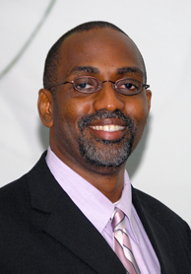
Mr. Ian Blanchard, is an experienced leader with over 20 years experience and over the past 26 years, he has worked in many different countries, thus gaining wide experience and insight into various cultures and working practices. His passion for leadership and personnel development has seen him create the environment for the development of a number of talented leaders throughout his career including spearheading the Cable & Wireless Green shoots talent development program, & the LIME People Managers Forum in the Windward Islands; a leadership development program for people managers. He holds a HND in Telecommunications and an MBA from Brunel University.

AGENDA:

Thursday 18th July, 2013
9:00 AM The Spirit of Leadership – Ian Blanchard
Identifying your leadership style

10:00 AM COFFEE BREAK
10:30 AM Assessing your ability to effectively lead others
Understanding the negative impact of over and under supervision on performance and morale
12:00 PM LUNCH
1:00PM Case Study
3:00 PM COFFEE BREAK
3:30 PM Q&A Session
5:00 PM End

Friday 19th July, 2013
9:00 AM Leadership Workshop – Catching, Motivating and Keeping the Best Employees during Tough Economic Times” by Dr. Earl Suttle
10:00 AM COFFEE BREAK
10:30 AM Leadership Workshop
12:00 PM LUNCH
1:00PM Leadership Workshop - Continued
3:00 PM COFFEE BREAK
3:30 PM Questions & Answer Session
5:00 PM End


Time | Theme: LACNIC & Internet Governance | Theme: Security and Stability | Theme: IPv6
8.00 - 9.00 | Registration
9.00 - 10.30 | Opening Ceremony (CANTO, CTU, LACNIC) | IXPs & Peering | Workshop: Introduction to IPv6 | Workshop: IPv6 for decision makers
9.00 - 10.30 | LACNIC Presentations: Services and Projects | IXPs & Peering | Workshop: Introduction to IPv6 | Workshop: IPv6 for decision makers
9.00 - 10.30 | LACNIC Registration Services | IXPs & Peering | Workshop: Introduction to IPv6 | Workshop: IPv6 for decision makers
9.00 - 10.30 | Certiv6 | IXPs & Peering | Workshop: Introduction to IPv6 | Workshop: IPv6 for decision makers
9.00 - 10.30 | Amparo, Frida, Ayitic | IXPs & Peering | Workshop: Introduction to IPv6 | Workshop: IPv6 for decision makers
10.30 - 11.00 | Coffee Break
11.00 -12.30 | Panel: Internet Governance (1) | BGP Routing | Workshop: Introduction to IPv6 | Workshop: IPv6 for decision makers
12.30 - 14.00 | Lunch Break
14.00 - 15.30 | Panel: Internet Governance (2) | Internet Critical Infrastructure Security (DNSSEC and RPKI) | Workshop: Introduction to IPv6 | Workshop: Information Security Incident Management
15.30 - 16.00 | Coffee Break
16.00 - 17.30 | LACNIC´s Policy Development Process  Policies under discussion in the Public Forum | Panel: Information Security Incident Management | Workshop: Introduction to IPv6 | Workshop: Information Security Incident Management
19.00 |  | Social Event - Cocktail

