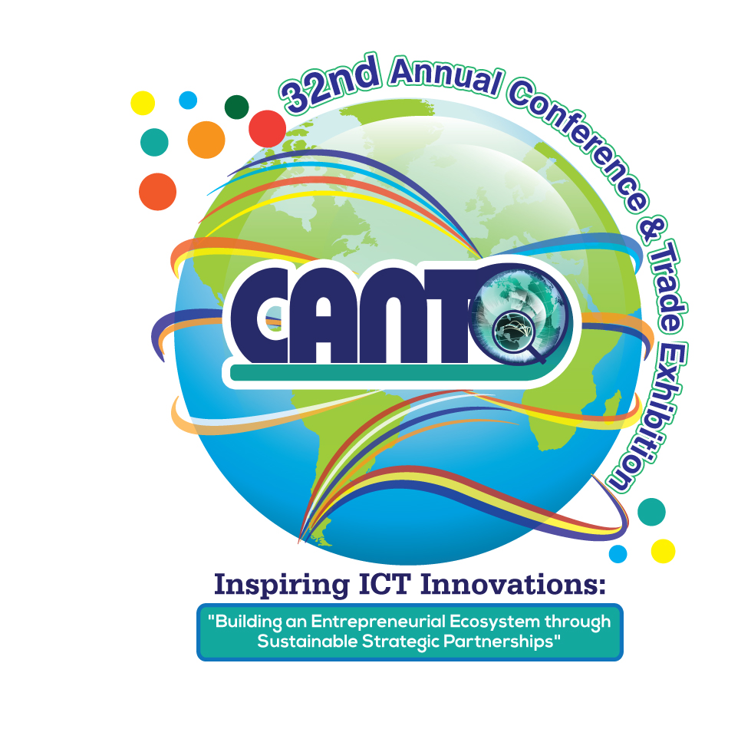
SPONSORSHIP OPPORTUNITIES

CATEGORIES | AMOUNT | SPONSORSHIP BENEFITS
Headline |  | - Opening Ceremony - Keynote  - Ministerial Panel (A) - Keynote  - One (1) Flagship Banner (20 x6)  - Two (2) (3x8) vertical banners  - Company logo displayed on event banner and website  - Public announcements at conference and exhibition  - Conference Rotary Ad (full page)  - Full Page Ad in conference program
Gold | US$40,000 | - Two (2) 10’ x 10’ Booths in the exhibition hall  - Full page color Ad. in the conference program  - Half page Ad. in the 3rd and 4th quarter of the 2015 Cancion  - Four (4) free passes for the event  - Company logo displayed on event banner and website  - Public announcements at conference and exhibition  - Conference Rotary Ad (full page)
Silver | US$35,000 | - One (1) 10’ x 10’ booth in the exhibition hall  - Full page color Ad. in the conference program  - Half page Ad. in the 3rd and 4th Qtr. of the 2015 Cancion magazine  - Three (3) free passes for the event  - Company logo displayed on event banner and website  - Public announcements at conference and exhibition  - Conference Rotary Ad (logo and tagline )
Bronze | US$25,000 | - One (1) 10’ x 10’ booth in the exhibition hall  - Half page Ad. in the conference program  - Two (2) free passes for the event  - Company logo visibly displayed on event banner and website  - Public announcements at conference and exhibition  - Conference Rotary Ad (logo and tagline)
CATEGORIES | AMOUNT | SPONSORSHIP BENEFITS
Trending Zone |  | - Rotary Ad – Big Screen  - 3 x 8 Banner  - Company tweets  - Company logo visibly displayed on event banner and webpage
Coffee Breaks (5)  Monday &Tuesday morning sold |  | - One (1) free pass  - Company logo visibly displayed on event banner and webpage  - Public announcements at the sponsored coffee break  - Conference Rotary Ad (logo and tagline )
Monday Ministerial Panel/Round Tables (Panel 1 and 2) |  | - Keynote  - Two(2) 3 x 8 banners  - Full page Ad. in the conference program  - Company logo visibly displayed on event banner and webpage  - Public announcements at the sponsored coffee break  - Conference Rotary Ad (logo and tagline
Lunches (3) | US$25,000 (3 stations) | - Three (3) free passes  - Full page Ad. in the conference program  - Company logo visibly displayed on event banner and webpage  - Public announcements at sponsored lunch  - Conference Rotary Ad (logo and tagline )
 | US$10,000 (per station) | - One (1) free pass  - Company logo visibly displayed on event banner and webpage  - Public announcements at the sponsored lunch  - Conference Rotary Ad (logo )
Ministerial Cocktail |  | - Three (3) free passes  - Full page Ad. in the conference program  - Ten minute presentation time  - Company logo visibly displayed on event table tents and webpage  - Public announcements at sponsored dinner  - Conference Rotary Ad (logo and Tagline)
Monday  Dinner |  | - Three (3) free passes  - Full page Ad. in the conference program  - Ten (10) minute presentation time  - Company logo visibly displayed on event table tents & webpage  - Public announcements at sponsored dinner  - Conference Rotary Ad (logo and Tagline )
Tuesday Members’ Dinner | US$25,000 | - Two (2) free passes  - Full page Ad. in the conference program  - Ten minute presentation time  - Company logo displayed on event table tents & webpage  - Public announcements at sponsored event  - Conference Rotary Ad (logo and Tagline )
CATEGORIES | AMOUNT | SPONSORSHIP BENEFITS
Breakfast (2)

Wednesday Dinner | US$25,000 | - Three (3) free passes  - Full page Ad. in the conference program  - Ten minute presentation time  - Company logo displayed on event table tents and webpage  - Public announcements at sponsored event  - Conference Rotary Ad (logo and Tagline)
Conference Bags* | US$15,000 | - Two (2) free passes  - Sponsor’s logo will be placed on bag (All delegates will receive a bag)  - Company logo displayed on event banner and webpage  - Conference Rotary Ad (logo)
T- Shirts* | US$15, 000 | - Two (2 ) free passes  - Logo on polo shirts (to be worn by all delegates)  - Company logo displayed on event banner and webpage  - Conference Rotary Ad (logo)
Conference Program * | US$10,000 | - One (1) free pass  - Full page color Ad. in back cover of conference program  Company logo displayed on event banner and webpage  - Conference Rotary Ad (logo)
Cancion Magazine* | US$10,000 | - One (1) free pass  - Full page color Ad. in conference edition of Cancion Magazine  - Company logo displayed on event banner and webpage  - Conference Rotary Ad (logo)
Annual Directory* |  | - One (1) free pass  - Full page color Ad. in annual directory  - Company logo displayed on event banner and webpage
Lanyards |  | - Company logo on item and logo visibly displayed on event banner and webpage  - Conference Rotary Ad (logo)
Powebank
Wrist Bands*
Banners
NB: Items marked with an *(asterisk) are time sensitive and must be sponsored before a certain timeframe (TBD) to facilitate shipping and sposorship commitments

10th Annual Human Resource Forum
This two day event features HR Training and best practices to support CANTO members. The program will offer the following categories of sponsorship:
Coffee Breaks (4) US$1,500 each
Lunches (2) US$3,000 each

3rd Annual Marketing Forum
This two day Interactive forum event features best practices in Marketing and Sales in the Telecoms /ICT sector. The program will offer the following categories of sponsorship:
Coffee Breaks (4) US$1,500 each
Lunches (2) US$3,000 each
Important

In kind sponsorship of promotional giveaways such as early-bird prizes and raffles during the conference will include the following items:

- * Cellular phones * Phone cards * Ipods * 2 Way Radios * Webcasting
- Additional benefits for Gold, Silver, Bronze and sponsorship above US$30,000
- Prominent high visibility signage in the conference, exhibition halls, event website and conference program
- Opportunity to distribute product/service literature in the conference bags

Sponsors of Events
Sponsors may supply logo imprinted napkins, cups or other such items for distribution at the respective sponsored event

CONTACT
Carmen - cramlal@canto.org
Tricia - tbalthazar@canto.org
TEL: +1(868) 622-3770/4781/5582/0929 FAX: +1(868) 622-3751

