REGISTRATION FORM:

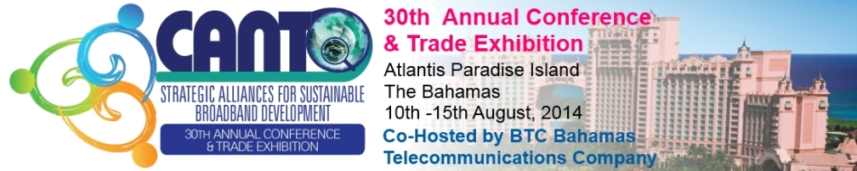
8th Annual HR Forum
The New Social Economy:
Rebooting HR for the Digital Age

14th – 15th August, 2014
Atlantis Paradise Island,
The Bahamas

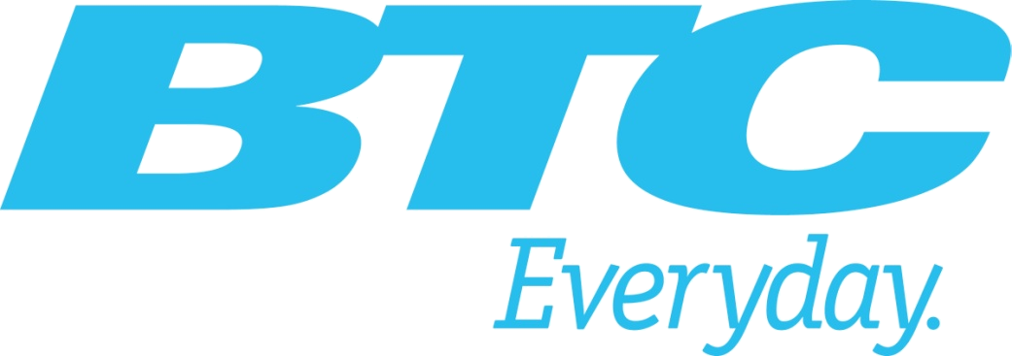
Please complete this form and return to the CANTO Secretariat by 25TH July, 2014
Participants will be required to make their own hotel reservations at http://canto.org/events-conferences/annual-conference-and-trade-exibition/hotel-information

NB: Please check for visa requirements for entry into The Bahamas.

NAME: _______________________________________________________________

ORGANIZATION: _______________________________________________________

COUNTRY: ____________________________________________________________

POSITION: _____________________________________________________________

TELEPHONE: ( ) _____________________ FAX: ( ) _______________________

EMAIL: ________________________________________________________________

 | DATE | TIME | FLIGHT NO. | AIRLINE
ARRIVAL

DEPARTURE

Non Members US$750

Members US$500

Payment Details Cash Cheque Wire Transfer Credit Card

Visa Master Number_________________________________ Exp. Date_________________

