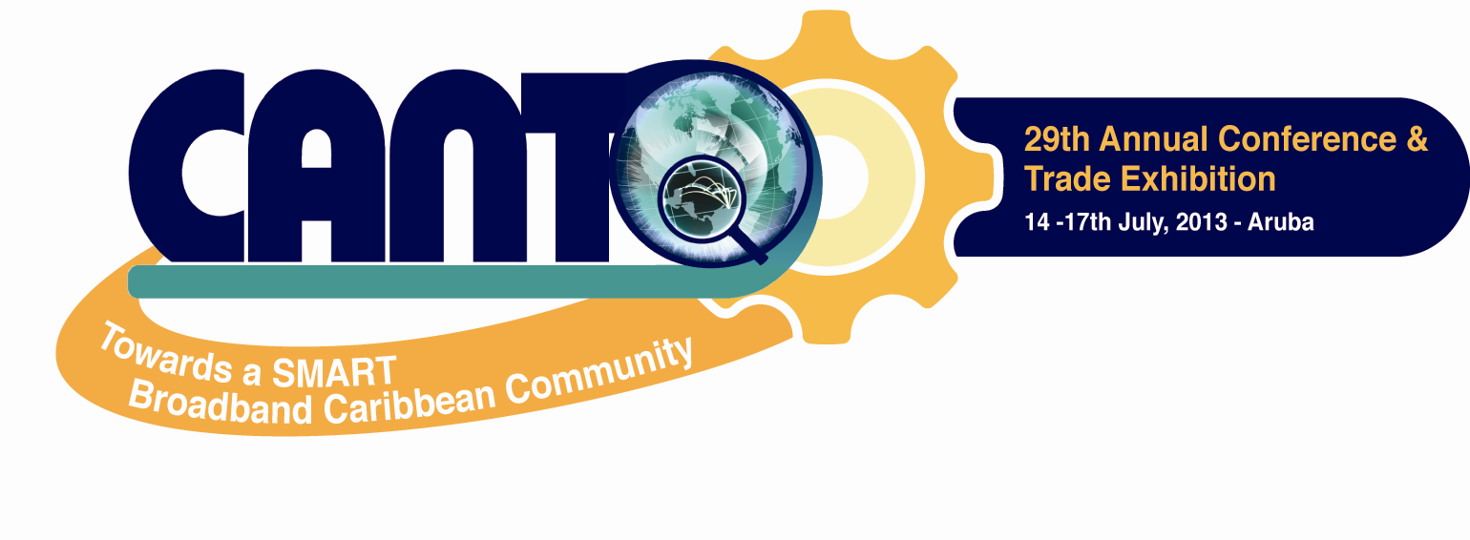


CALL FOR EXHIBITORS - CANTO 2013

CANTO invites you to be part of the 29th Annual Telecommunications Conference and Trade Exhibition 2013. CANTO 2013 is the Caribbean’s premier telecommunications event for industry professionals, academics and regional governments. The CANTO 2013 theme of: “Towards a SMART Broadband Caribbean Community”, will seek to hold meaningful discourse as we move towards information driven society. The event will be held at the Renaissance Convention Center, Aruba from the 14th – 17th July, 2013.

The trade exhibition will cover the spectrum of communications technologies, offering in-depth information on the latest developments in voice, data, image, e-content and multimedia captured in 67 exhibits.

As an exhibitor there are several key benefits to attending:

- Networking
- Showcasing your products and services to operators in the region
- Learning about state of the art and upcoming technologies
- Competitive analysis
- Discussing key telecommunication issues

CANTO sets the stage to:

- Network
- Establish an image for your company, product and service
- Develop presence and credibility

Operators, suppliers, exhibitors, regulators and all ICT related personnel, mark your calendars for this premier telecommunications event of the Caribbean – CANTO 2013, 14th – 17th July in Aruba.

For more information please contact:

Carmen Ramlal Administrative Assistant / Marketing
Tel: (868) 622-4781/3770/0929
Email: cramlal@canto.org

VISIT our website at www.canto.org

