33rd ANNUAL CONFERENCE & TRADE EXHIBITION
16th – 19th July, 2017
Theme: “Reimagining ICT as a Tool for National Growth and Development”

VENUE: Hard Rock Hotel & Casino
Punta Cana, Dominican Republic

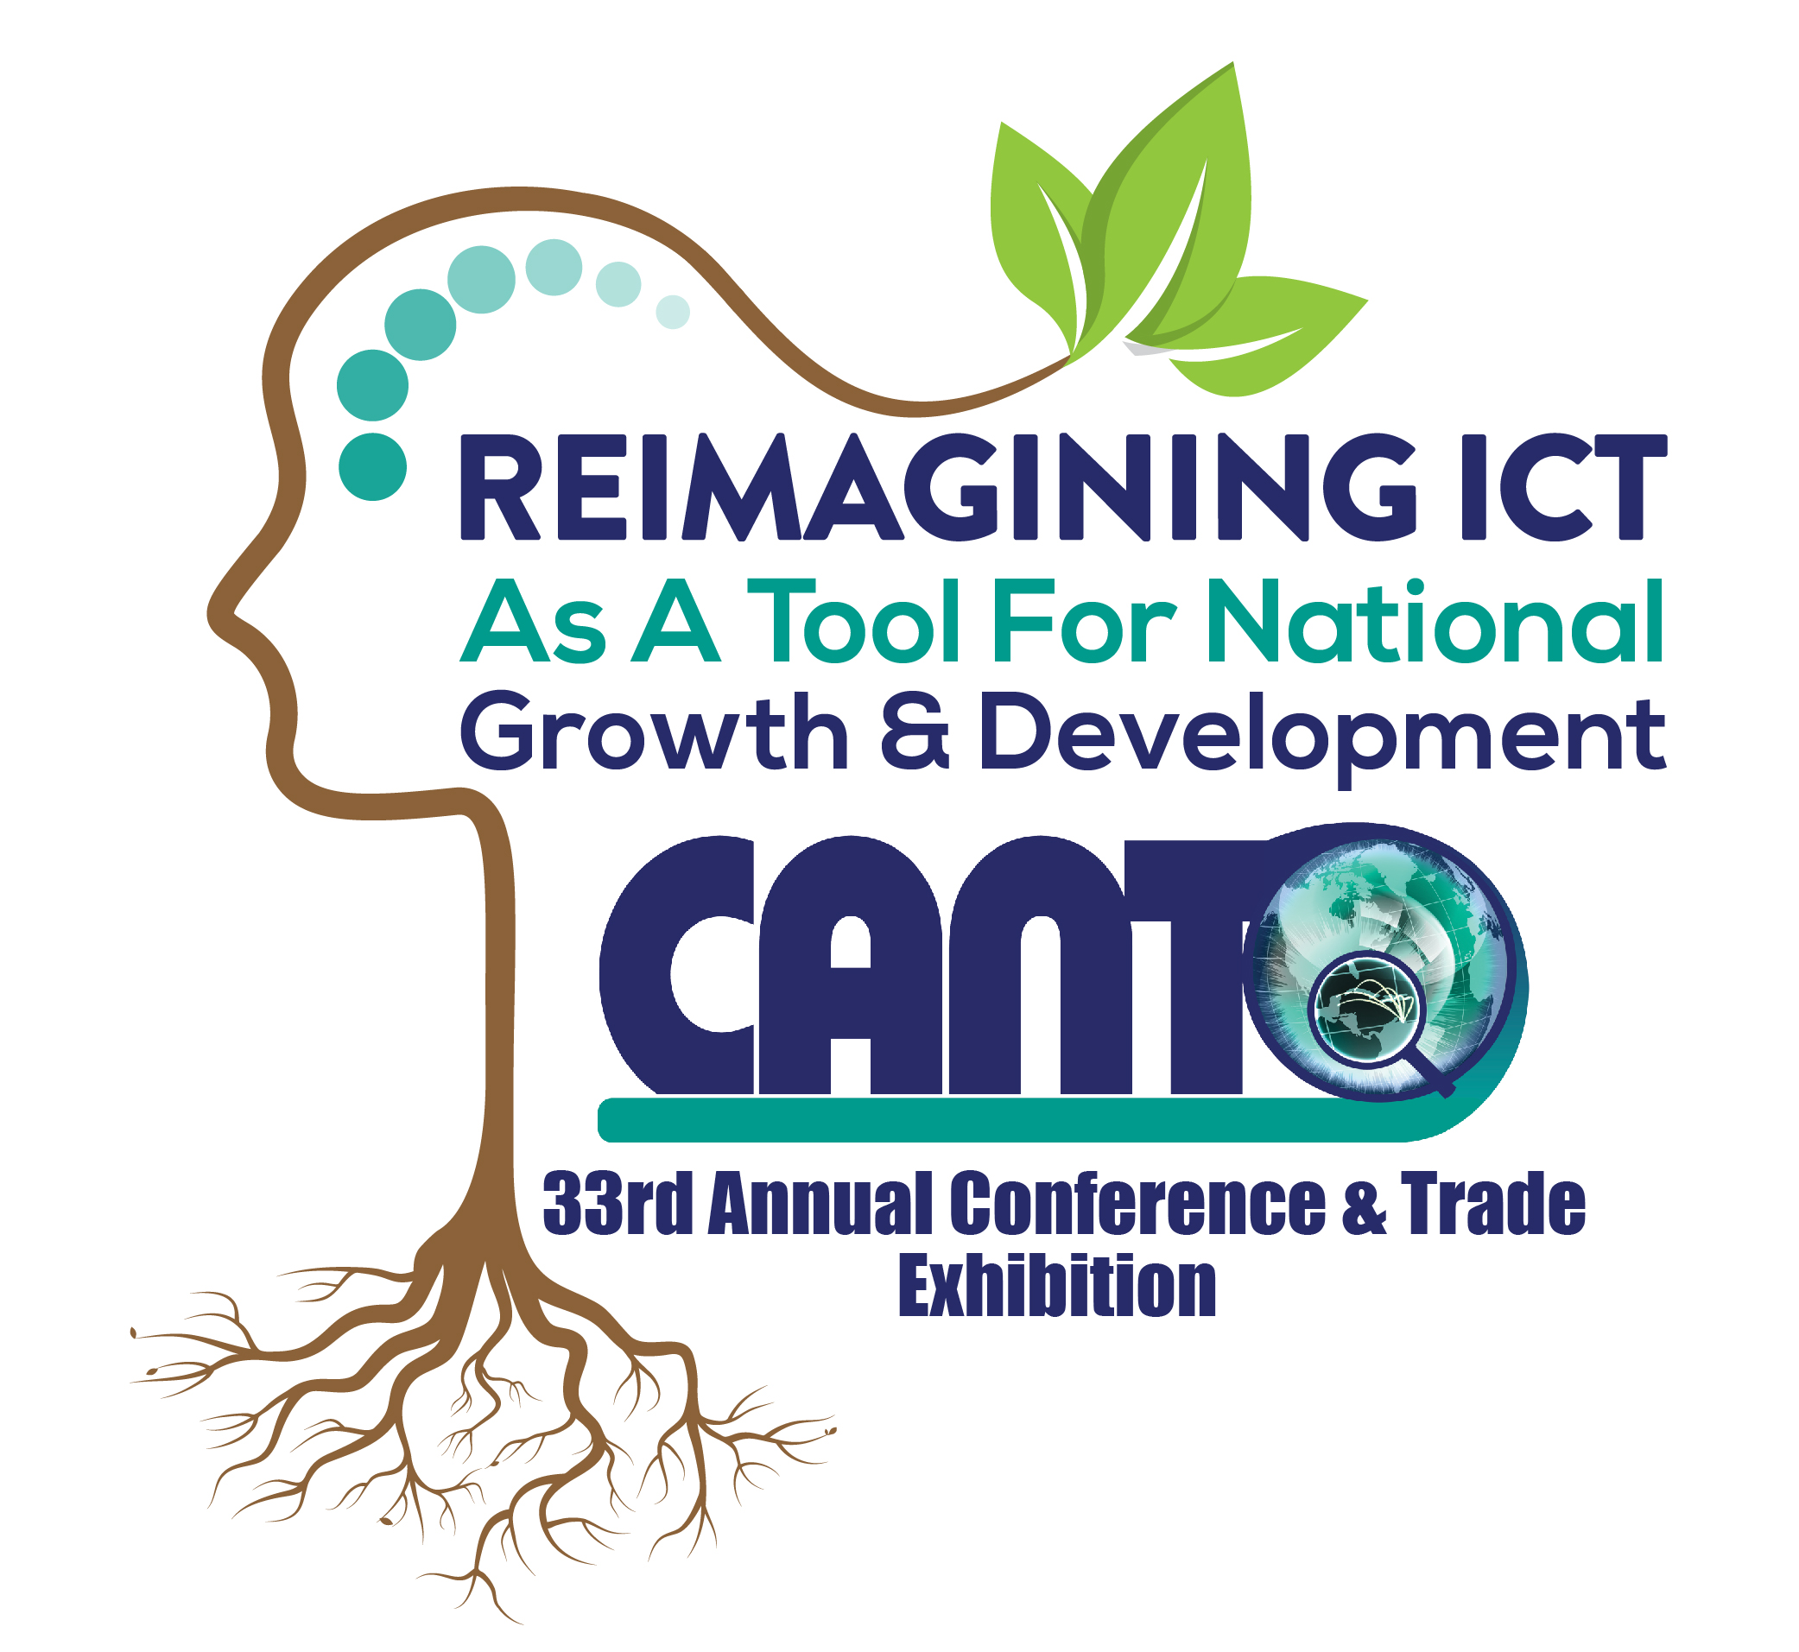EXHIBITION COMMITMENT FORM

To register, please complete this application form and return to the CANTO Secretariat for the attention of Ms. Carmen Ramlal – Administrative Assistant, Marketing & Sales Assistant at 67 Picton Street, Newtown, Port of Spain, Republic of Trinidad and Tobago. Fax: (868) 622-3751 Email: cramlal@canto.org; The deadline for submission is 30th June, 2017.

LAST NAME ________________________________ FIRST NAME__________________________________

TITLE_______________________________________________________________________________________

COMPANY___________________________________________________________________________________

ADDRESS____________________________________________________________________________________
‘

CITY ________________________________________STATE_______________________________________

ZIP__________________________________COUNTRY______________________________________________

TELEPHONE_____________________FAX________________________E-MAIL_________________________

WEBSITE: ______________________

Number of Booths required:
Please indicate Booth numbers in order of preference.

1 __________
2 __________
3 __________
4 __________
5 __________
Booths | Dimensions (ft) | Cost per booth (US)  Exclusive Space | Cost per booth (US)  Premium Space | Cost per booth (US)  Regular Space
22-31 & 54-55 | 10ft x 10ft | 5,000.00
12-21, 32-46, 51-53 & 56-62 | 10ft x 10ft |  | 4,500.00
01-11, & 47-50 | 10ft x 10ft |  |  | 4,000.00
See Floor plan for Exclusive, Premium & Regular booths
BOOTH COST PER
NUMBERS SIZE BOOTH US$

01 – 70 10’ X 10’ 2.500.00
NOTE
- A 50% non-refundable down payment must be submitted with the signed copy of this Form. The 50% balance of payment will be payable within 14 days of the issue of a CANTO invoice. Written cancellations after 16th June, 2017 will result in a penalty of 50% of the cost of the booth.
NO REFUND will be made after 30th June, 2017
2. Booths will only be reserved on receipt of the 50% down-payment.
3. Your commitment form must be accompanied by a 75 word overview of your company and your company logo in jpg or eps format.

Date: …………………………….. Signature: ………………............. dd mm yy

