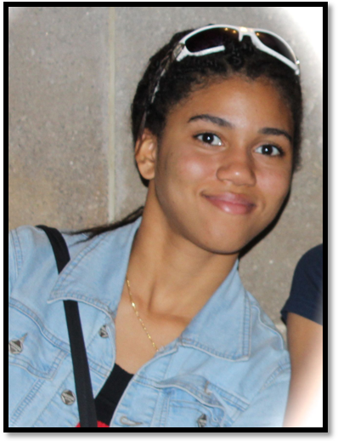
Hi! My name is Gionieva Fraser and I am 18 years of age. I am currently at the end of my Upper Sixth Form year at St. Joseph's Convent, Port - of - Spain, where I am completing examinations in CXC CAPE Unit 2 Mathematics and Physics. Soon, I will be off to university to pursue a degree in Aerospace Engineering. However, despite my interest in science, engineering and mathematics, I also developed a deep love for music, painting and the literary arts from a very young age. Consequently, I have enjoyed playing the piano and writing articles for the Trinidad Guardian GIE Network magazine. I have also entered and won several national essay writing competitions and in 2013 I placed 2nd in CANTO's WTISD Essay Writing Competition. This year, when I realised that CANTO's annual WTISD competition was changed to a video competition I was up for the challenge! Although I knew little about videography, I was eager to try my hand at something new. Along the way, I learned invaluable skills in photography and videography (not to mention Broadband for Sustainable Development) that I'm sure will assist me in my future endeavours. Storyboarding, shooting and editing this video was by no means an easy job, but thankfully, my hard work paid off!

