Marketing & Communications Committee Meeting
24th September , 2015
MINUTES

Attendees:
Joseph Samuel, , Tricia Balthazar, Julian Wilkins

Agenda

1. Approval of Draft Agenda
2. Action Status
3. Competitions (Updates)
• i-Create/ Hackathon Competition
• WTISD Video Competition
4. 32nd AGM - Haiti
5. 2016 theme
6. Marketing Plan
7. Revenue Generating Initiatives
8. A.O.B
9. Closing
10. Date of Next Meeting

- Opening and Approval of Draft Agenda

The meeting commenced at 3:40PM
- Action Status
None

- Competitions

- WTISD - Ongoing ITU’s WTISD theme to be changed to “Inspiring ICT Innovations: Building an Entrepreneurial Ecosystem through Sustainable Strategic Partnerships”.
  - Effectively communicate information
  - Ministry of Education
  - Utilize members to push information /advertisement
  - Update – Flyer complete
- i-Create Future of I-Create 1st Annual C.O.D.E.

Sponsored by: DSS Domus Semo Sancus Facilitator: PIEDATA

Action 190: Determine if DSS will continue sponsorship

- 32nd Annual AGM – Haiti
This will be co-hosted by Digicel Haiti
Action 191: Circulate Agenda for input to core team

- 2016Theme
Joseph suggested 2 themes
The theme selected by the BoD is: Inspiring ICT Innovations: Building an Entrepreneurial Ecosystem through Sustainable Strategic Partnerships”.
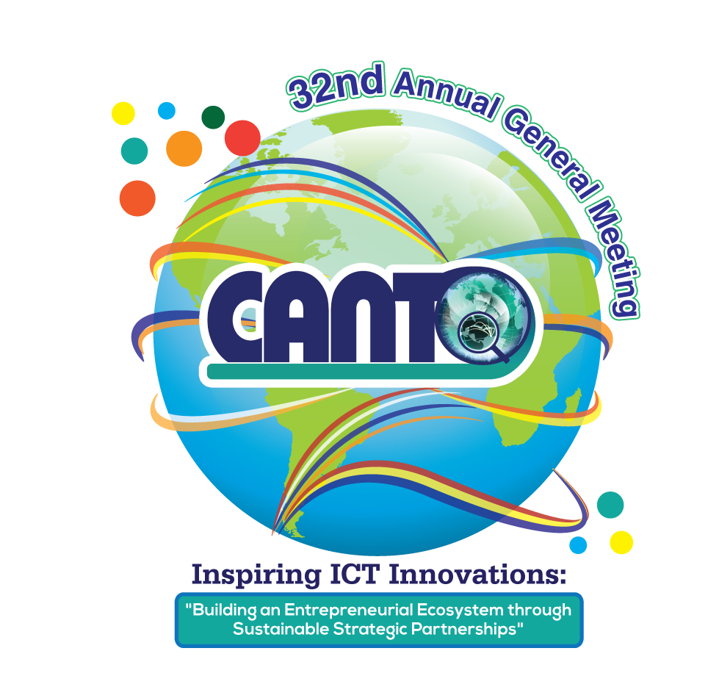

- Marketing Plan
The team is charged with the responsibility of creating a marketing plan which will follow the lead of the strategic plan.
The Marketing Plan was completed and added to agenda for discussion . A high level overview will be given to the board by the Chair at the AGM
Revenue Generating Initiatives (Stet)

- Silent Auction.
- CANTO may seek the following items sponsored and keep the proceeds from the sale:
  - Hotel Stay
  - Car Rentals
  - Latest Smart Phone
  - Tablet

- CANTO Collectors’ Items – Memorabilia
Create Limited Edition items and sell at premium prize at the Event. e.g. high end Polo shirts
- Vacancies. Charge a fee for listing vacancies on the CANTO Website
- Advertisements
  - Push Ads for CANTO App
  - Develop YouTube Channel to be more active and to generate traffic
- Discuss status and course of action for the next Marketing Committee meeting.
Updated
- Include sub categories forISP provider
- Conduct VOS survey at AGM to determine membership needs
- Procure telecommunications statistics on ICT/Teecoms for the region for resale

- A.O.B
All sub events should be under the umbrella theme: “Inspiring ICT Innovations: Building an Entrepreneurial Ecosystem through Sustainable Strategic Partnerships”.
Action192: Request revenue generating ideas from core team
- Closing:
Meeting ended at 5:00PM
- Date of Next meeting Face to Face meeting Call
Thursday 19th November, 2015 3:30PM AST

