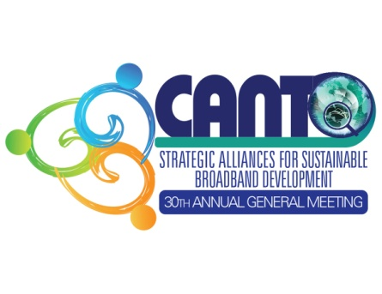 | 30th Annual General Meeting  “Strategic Alliances for Sustainable Broadband Development”  25th to 28th January, 2014  Half Moon Hotel  Rose Hall, Montego Bay, Jamaica  Co-hosted by: LIME  AGM DOCUMENTS

