

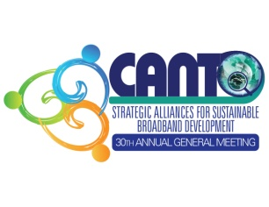

**30th Annual General Meeting**

**25th -28th January, 2014**

**Half Moon Hotel, Rose Hall, Jamaica**

**Theme: “*Strategic Alliances for Sustainable Broadband Development”***

**Agenda**

**Corporate Social Responsibility (CSR) Committee**

**26th February, 2014**

**12:00 noon – 1:00 pm**

**St. Elizabeth**

1. **Opening remarks**
2. **Approval of Agenda**
3. **Terms of Reference**
4. **Best practices – handset Disposal**
5. **The Global Telecommunications Initiative**
6. **Identifying other Best Practices**
7. **A.O.B**
8. **Date of next meeting**