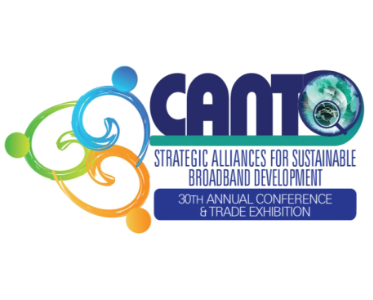
“STRATEGIC ALLIANCES FOR SUSTAINABLE BROADBAND DEVELOPMENT”

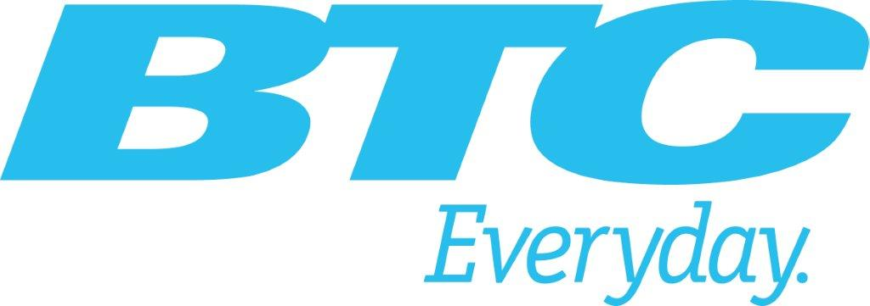



CANTO 30TH ANNUAL CONFERENCE & TRADE EXHIBITION
10TH – 13TH AUGUST, 2014

CANTO 8TH ANNUAL HUMAN RESOURCE FORUM
14TH – 15TH AUGUST, 2014
CANTO 1ST ANNUAL MARKETING FORUM
14TH – 15TH AUGUST, 2014
ATLANTIS, PARADISE ISLAND
THE BAHAMAS

Saturday 9 August 2014

CLOSED SESSION: CANTO BOARD OF DIRECTORS MEETING
10:00 am – 4:00 pm

CLOSED SESSION: CANTO BOARD OF DIRECTORS NETWORKING DINNER
7:00 pm – 10:00 pm

Sunday 10 August 2014

CANTO COMMITTEE MEETINGS
9:00 am -12:00 am | CANTO Committee Meetings  Marketing and Communications Committee Meeting - 9:00 am  Regulations and Emerging Technologies Committee Meeting - 10:00 am  Financial Advisory Committee Meeting – 10:00 am  Disaster Preparedness Committee Meeting – 11:00 am  Human Resource Committee Meeting - 10:00 am  Corporate Social Responsibility Committee Meeting – 11:00 am

CLOSED SESSION: COMMITTEE CHAIRS PRESENTATION TO CANTO BOARD
12:00 – 1:30 pm | Financial Advisory Committee  Marketing and Communications Committee  Regulations and Emerging Technologies Committee  Human Resource Committee  Disaster Preparedness Committee  Corporate Social Responsibility Committee

PRESS CONFERENCE
3:00 – 4:00 PM | Chair: Ayanna Samuels, Consultant  - Welcome Remarks, Regenie Fräser, CANTO  - WTISD presentation to  - Remarks on behalf of BTC  - Remarks, on behalf of CANTO, Dirk Currie, CANTO Chair  - Vote of Thanks,
OFFICIAL OPENING CEREMONY OF CANTO 2014
6:00 – 7:00 pm | Government Ministers, CANTO Executives, and Members, Officials of The Bahamas and other dignitaries in attendance  MC:  - Opening Prayer  - National Anthem  - CANTO Song  - Pride & Passion in Innovation, Dr. Earl Suttle  - Welcome Remarks: Geoff Houston, Chief Executive Officer, BTC  - Opening Remarks: Ms. Regenie Fräser, Secretary General, CANTO  - Remarks from CARICOM: Irwin LaRocque, Secretary General, CARICOM (invited)  - Chairman’s Remarks: Mr. Dirk Currie, Chairman, CANTO Board of Directors  - Feature Address: Dr Hamadoun Touré, Secretary General, ITU  - Address: The Rt. Hon. Perry Gladstone Christie, Prime Minister & Minister of Finance  - Vote of Thanks: BTC  Procession towards opening of Exhibition and Welcome Reception  Please follow instructions of MC for procession towards Exhibition and Welcome Reception
7:00 – 9:00 pm | RIBBON CUTTING, EXHIBITION VIEWING & COCKTAIL RECEPTION

Monday 11 August 2014
CLOSED SESSION: LIME SPONSORED Ministerial Breakfast Briefing

7:00 – 8:30 am | Chair: Regenie Fräser, Secretary General, CANTO  - Dirk Currie, CANTO Chair  - Chris Dehring, Chairman, LIME

CONFERENCE OPENING:

9:00 – 9:30 am | Chair:  - Mitzi Miller, Editor in Chief, Ebony Magazine  - Honourable Keith Mitchell, Prime Minister of Grenada and Minister with Responsibility for ICT in CARICOM (invited)

Ministerial Roundtable: DIGICEL SPONSORED : Strategic Alliances for Sustainable Broadband Development

9:30 -11:00 am | Moderators: Dirk Currie, CANTO Chair & Karen Bevans, CANTO Vice Chair  - KEYNOTE: Ericsson
11:00 – 11:15 am | COFFEE Sponsored by

Ministerial Roundtable: DIGICEL SPONSORED : Strategic Alliances for Sustainable Broadband Development

11:15 am – 1:00 pm | Moderators: Dirk Currie, CANTO Chair & Karen Bevans, CANTO Vice Chair  - KEYNOTE – Huawei
1:00 – 2:00 pm | LUNCH

1:00 – 5:00 pm | EXHIBITION VIEWING

Public/Private Sector Dialogue on CARICOM Single ICT Space
2:00 – 4:00 pm | Chair: Hon. Keith Mitchell, Prime Minister of Grenada with responsibility for ICT in CARICOM (invited)

Connect the Caribbean Project of the Year
4:00 – 5:00 pm

5:30 – 6:30 pm | ARIN & LACNIC Private Cocktails  By invitations only

7:00 – 10:00 pm | CANTO ERICSSON DINNER  Open to all delegates
Tuesday 12 August 2014

WOMEN in ICT BREAKFAST SPONSORED BY
7:00 – 8:30 am | This session seeks to: recognize women who have made remarkable strides in the Caribbean ICT Sector; promote awareness and interest in ICT careers for women and girls; and examine potential ICT projects for women and girls  Chair: Regenie Fräser: Secretary General, CANTO

Track 1: Regulators Roundtable Discussion
9:00 -10:45 am | Chair: CANTO Director  This track will address how service providers must adapt as the pace of demand for broadband capacity is increasing dramatically while keeping up with regulatory requirements  - Keynote:  - TATT  - NTRC, St. Vincent and the Grenadines  - OCCUR
10:45 – 11:00 am | COFFEE: SPONSORED BY

Track 2: Operators Roundtable Discussion
11:00 am – 1:00 pm | Panelists: Coyote System Inc  - Keynote:  - TSTT  - Adding TV to the Business Model for Operators, TELESUR

CLOSED SESSION: BIIPAC Technical Committee Meeting for IDB Members
11:00 am – 1:00 pm | Broadband Infrastructure Inventory and Public Awareness Project in the Caribbean dialogue with Technical Committee members

1:00 – 2:00 pm | LUNCH

Track 3: Big Data: Transforming how we live, work and think through ICT Development
2:00 pm – 4:00 pm | Chair: Davidson Charles, CANTO Director  This track will address evolving standards, technologies, policies and market potential for cloud solutions, architectures and best practices  Topics:  - KEYNOTE:  - Julian Wilkins, Digicel Trinidad and Tobago  - Government Data in the Clouds  - Cost efficiency in company expenditure  - Cloud services availability

1:00 – 5:00 pm | EXHIBITION VIEWING

7:00 – 10:00 pm | CANTO MEMBERS, SPONSORS AND VIPs DINNER Sponsors by Facey and Oberthur  By Invitations Only
Wednesday 13th August 2014

Track 4: The Future of Telco Marketing: content, timing and channels for success
9:00 -10:45 am | Chair: Julian Wilkins, CANTO Director  - Keynote:  - Trends in the Internet of Things  - What’s the next big thing for communications  - How Telcos and start ups can partner to build a successful apps eco system  - Focus on experience
10:45 – 11:00 am | COFFEE

Track 5: Mobile Multimedia: Opportunities and Challenges for Mobile Operators
11:00 am – 1:00 pm | This session will focus on mobile network operator’s position and opportunity to play a key role in bringing SMEs and consumers together, motivating new offers and assisting with transactions. Chair: Lawrence Mc Naughton, CANTO Director  - Keynote:
CLOSED SESSION: BIIPAC Steering Committee Meeting for IDB Members
11:00 am – 1:00 pm | Broadband Infrastructure Inventory and Public Awareness Project in the Caribbean dialogue with steering committee members.

1:00 – 2:00 pm | LUNCH

1:00 – 5:00 pm | EXHIBITION VIEWING
Track 6: IPv6 is Here – Are the Impacts Real?
2:00 – 4:00 pm | Chair:  This track will look at the implications of the depletion of IPv4 numbers and the transition to IPv6  - Keynote: Arin  - Internet Society  - Lacnic  - FCC
7:00 – 9:00 pm | BTC & Icemobile Cocktail Extravaganza &Closing Ceremony

CANTO 8TH ANNUAL HUMAN RESOURCE FORUM
14TH – 15TH AUGUST, 2014

AGENDA TO BE FINALIZED:

CANTO 1ST ANNUAL MARKETING FORUM
14TH – 15TH AUGUST, 2014

AGENDA TO BE FINALIZED:

