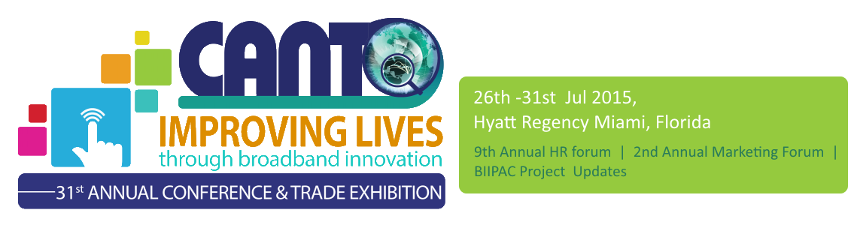
31st Annual Conference and Trade Exhibition
26th – 29th July, 2015

9th Annual Human Resources Forum
30th – 31st July, 2015

2nd Annual Marketing Forum
30th – 31st July, 2015

Saturday 25 July 2015

Closed Session: CANTO Board of Directors Meeting
9:00 – 5:00

Sunday 26 July 2015

CANTO Committee Meetings
9:00 – 12:00 | Marketing and Communications Committee Meeting - 9:00 am  Regulations and Emerging Technologies Committee Meeting - 10:30 am  Financial Advisory Committee Meeting – 12:00 noon  Disaster Recovery Planning Committee Meeting – 9:00 am  Human Resource Committee Meeting - 10:30 am  Corporate Social Responsibility Committee Meeting – 12:00 pm

Closed Session: CANTO Committee Chairs Presentation to the Board
2:00 -3:00 | Marketing and Communications Committee Meeting - 2:00pm  Regulations and Emerging Technologies Committee Meeting - 2:10pm  Financial Advisory Committee Meeting – 2:20pm  Disaster Recovery Planning Committee Meeting – 2:30pm  Human Resource Committee Meeting - 2:40pm  Corporate Social Responsibility Committee Meeting – 2:50pm
Welcome Session
2:00 -3:00

Official Opening of CANTO 2015
6:00 | Government Ministers, CANTO Executives, and Members, Officials of The Bahamas and other Dignitaries in attendance  Opening Ceremony:  - MC – Leon Williams, Chief Executive Officer, BTC Bahamas  - Presentation of National Flags  - National Anthem of the Republic of Trinidad and Tobago  - Invocation - CANTO Song  - Welcome Remarks: Ms Regenie Fräser, Secretary General, CANTO  - Remarks: Mr. Julian Wilkins, Chairman, CANTO Board of Directors  - Keynote Address:  - Cultural performance  - Vote of Thanks: Helma Etnel, CANTO Treasurer
7:30 | Opening of Exhibition and Cocktail Reception

Monday 27 July 2015 – Track 1 Riverside South

Ministerial Roundtable 1: C&W SPONSORED: Improving Lives through Broadband Innovation
9:00 | Cable and Wireless SPONSORED: Improving Lives through Broadband Innovation  Moderators: Julian Wilkins, CANTO Chair & Leon Williams, CANTO Vice Chair  - KEYNOTE – Huawei
11:00 | COFFEE BREAK

Ministerial Roundtable 2: DIGICEL SPONSORED: Improving Lives through Broadband Innovation
11:15 | DIGICEL SPONSORED: Improving Lives through Broadband Innovation  Moderators: Julian Wilkins, CANTO Chair & Leon Williams, CANTO Vice Chair  - KEYNOTE – Ericsson
1:15 | Lunch and Exhibition Viewing

Session 1: The New Mobile Identity
2:15 | New and important business opportunities for mobile operators created by the convergence of mobile and IT  Session Chair: EJay Saunders, CANTO Director  - KEYNOTE –  - The role of Telcos in Mobile Wallet, Diana Sirila, Digicel
4:00 | COFFEE BREAK in Exhibition Hall
Connect the Caribbean Project of the Year Award
4:15
 | Social Event
6:00

Tuesday 28 July 2015 – Track 2 - Riverside South

 | SESSION 2 :Operators Roundtable: The Innovation Edge
9:00 | Insights from Caribbean operators  Moderator:  - KEYNOTE – Etecsa, Cuba,  - Digicel  - Cable and Wireless  - Telesur  - Belize

11:00 | COFFEE BREAK

 | SESSION 3: Alcatel-Lucent SPONSORED: Caribbean Women In ICTs - Improving Lives through Broadband Innovation
11:15 | The impact of ICTs on empowering Women in the Region  Moderator:  - KEYNOTE – Alcatel Lucent
1:15 | LUNCH AND EXHIBITION VIEWING
 | SESSION 5: M2M and IoT Strategies |  | Session 6: Future Networks Systems and Security
2:30 | A discussion on the future of the M2M industry |  | The network of the future is envisioned as an effective, intelligent, adaptive, active and high performance Internet
4:00 | COFFEE BREAK
4:15 | DSS Sponsored Hackathon Update 1 In Exhibition Hall
 | Social Event
6:00

Wednesday 29 July 2015 – Track 4 Riverside South

Session 7: Regulators Roundtable: Regulating Innovation
9:00 | Moderator:  - KEYNOTE – Telecommunications Regulatory Commission, BVI  - Regulatory Frameworks that facilitates Innovation; Mark Reynolds, Digicel  - Spectrum Management Issues in the Caribbean; Bernadette Lewis, CTU
11:00 | COFFEE BREAK
 | Session 8: Capturing the Mobile Content Marketing in the Caribbean
11:15 | Capturing the Mobile Content Marketing in the Caribbean  Session Chair  - KEYNOTE –  - Mobile Performance within the overall Marketing Mix - Greg Stuart Mobile Marketing Association
1:15 | LUNCH AND EXHIBITION VIEWING
 | Session 9: Visions of 5G – Reality or Eventuality – a look into the Fundamental Changes in the Industry
2:15
4:15 | COFFEE BREAK
Announcement of Hackthon Winners and Demo of Prototype
 | Closing Event
7:00 pm

Thursday 30th July 2015

9th Annual Human Resources Forum

2nd Annual Marketing Forum

Friday 31st 2015

9th Annual Human Resources Forum

2nd Annual Marketing Forum

