 | FINANCIAL ADVISORY COMMITTEE AGENDA  Sunday 10th August 2014  10am  Hermes III Room  HOSTED BY  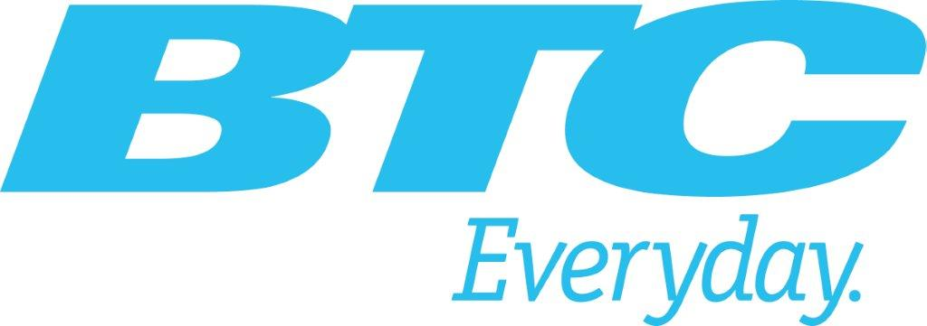 | 

- Opening
- Approval of the Agenda
- Review of Accounts as at 31 July, 2014
- Review of Draft Budget for year 2014/15
- Any other Business

