 | HUMAN RESOURCE COMMITTEE MEETING AGENDA  Sunday 10th August 2014  10am  Hermes II Room  HOSTED BY  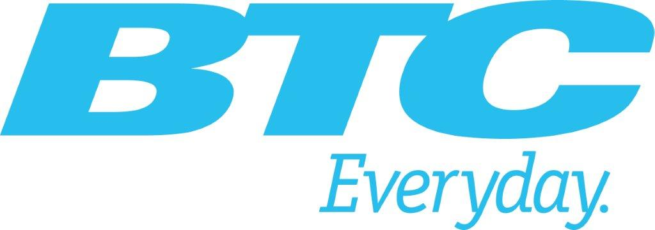 | 

- Opening
- Approval of the Agenda
- Review of Last Meeting Report
- Drafting of Position/Discussion or Information Papers
- 8th Annual Human Resources Forum
  - Attendance
  - Agenda
- Items to be pursued by Committee
- Any other Business

