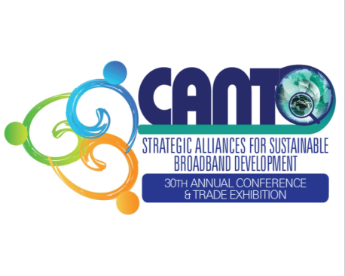 | MARKETING AND COMMUNICATION ADVISORY COMMITTEE AGENDA  Sunday 10th August 2014  9AM  Eros I Room | CO-HOSTED BY  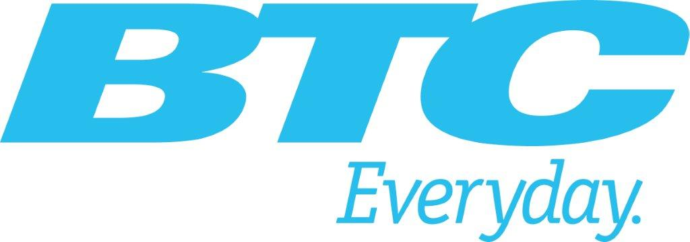

- Approval of Draft Agenda - 1 Min
- Action Status - 5 Mins
- Competitions - 10 Mins
    - i-Create/ New ICT Competition (7 Mins)
    - WTISD –Video competition – (3 mins)
- CANTO 2014/15 – Marketing Forum - Updates - 3Mins
- How can the Committee get members more committed and involved? - 10 Mins
- Revenue Generating Initiatives.- 20 Mins
- A.O.B - 10 Mins
- Closing - 1 Min
- Date of Next Meeting - 1 Min

