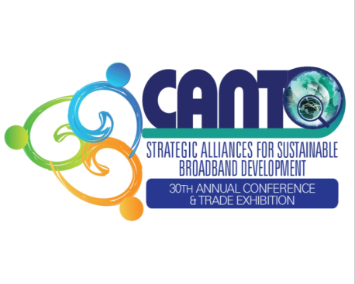 | FINANCIAL ADVISORY COMMITTEE AGENDA  Sunday 10th August 2014  10-11.30AM  Erros 2&3  HOSTED BY  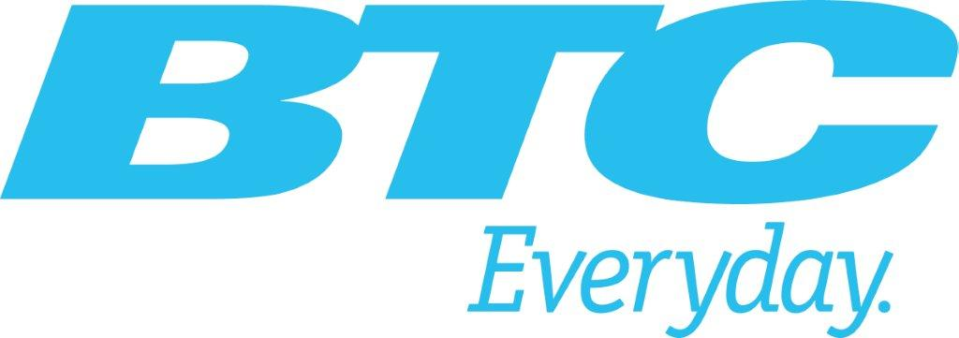 | 

REGULATIONS AND EMERGING TECHNOLOGIES COMMITTEE MEETING

- Opening
- Approval of Agenda
- Report of Committee Meeting 25 July 2014
- Status of Markets
- Preparation for WRC15
- Other Matters
- CANTO OTTs Policy Paper
- Closing

