PRESS RELEASE

CARIRI and CANTO sign MOU
The Caribbean Industrial Research Institute (CARIRI) and CANTO signed a memorandum of understanding on Wednesday 3rd September 2014 to work together to strengthen the region’s ability to develop, promote and commercialise mobile applications.
Both institutions have a shared interest to increase awareness regarding global and regional internet related challenges and governance; promote regional mobile app development; build regional technical expertise through mentoring and training and share knowledge and data on best practices to assist in the development of mobile apps programming. It is against this backdrop that the MOU commits the two institutions to sharing knowledge and expertise related to mobile application development in Trinidad and Tobago as well as across the region.
CEO of CARIRI, Mr Liaquat Ali Shah and Secretary General of CANTO, Ms Regenie Fraser were both on hand to sign the MOU for this new and innovative relationship which will benefit the region significantly.
At Freeport, CARIRI has the Centre for Enterprise Development which houses its own mCentre. The mCentre is a mobile applications lab which offers testing services to app developers to ensure that their apps are optimised and ready for commercialisation. CANTO has successfully held a mobile app competition for the last 3 years called iCreate and with this partnership, can now take the developers forward to reach their full commercialisation potential.
CARIRI and CANTO are making leaps and bounds in driving innovation and creating a space for people with mobile app ideas to develop them. CARIRI has been recognized as the leader in the field of consultancy, innovation and testing for over 44 years, while CANTO is recognized as the leading trade association of the ICT sector for shaping information and communication in the Caribbean. This is the perfect time for a partnership such as this as Trinidad and Tobago and the region gear up to start making inroads into the competitive world of mobile apps.
PICTURES
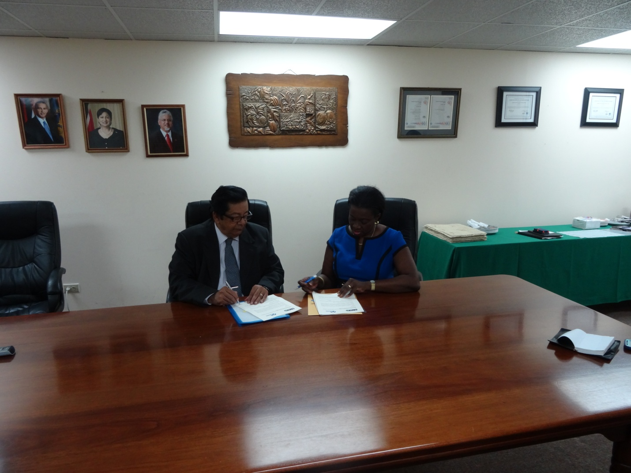
CEO of CARIRI, Mr Liaquat Ali Shah and Secretary General of CANTO, Ms Regenie Fraser signing the MOU

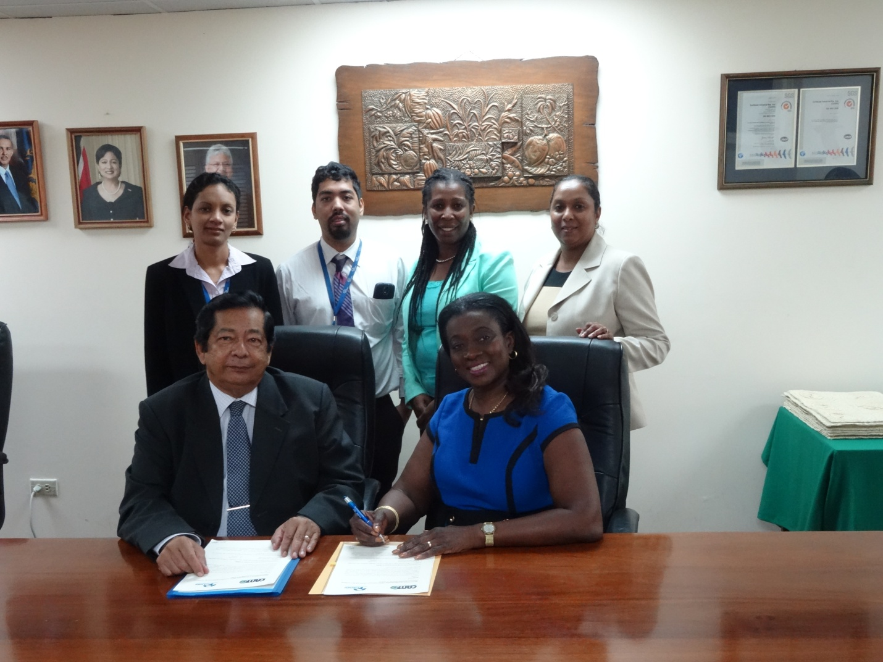
L-R: Golda Lushington and Che Achoy of CARIRI; Tricia Balthazar and Teresa Wankin of CANTO
Seated: CEO of CARIRI and Secretary General of CANTO

