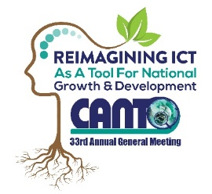 | 33rd Annual General Meeting  29^{th –} 31st January, 2017  Renaissance Hotel  Curacao

Corporate Social Responsibility (csr) Committee Meeting Agenda
Monday, 30th January 2017
Time: 1:00 pm – 2:30 pm

Chaired by: Julian Wilkins
Vice Chair: Gervon Abraham

Agenda
- Opening

- Approval of Draft Agenda

- CSR Workshop/ Forum

- People with disabilities & limited access to telecom ICT’s

- Paper 2- Take Back Prgramme

- Any other Business

- Date of next meeting

- Closing

