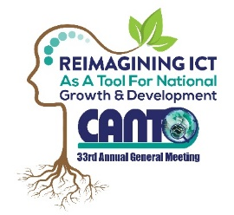 | 33rd Annual General Meeting  29^{th –} 31st January, 2017  Renaissance Hotel  Curacao

Disaster Risk Management Committee Meeting Agenda

Monday, 30th January 2017

Time: 1:00 pm – 2:30 pm
Ballroom A

Chaired by: Heather Wallen-Bryan – LIME, Jamaica
Vice Chair: Sherry Rolle – BTC, Bahamas

- Opening
- Approval of Draft Agenda
- Apologies
- Announcement
- Hurricane Simulation Report
- Matters Arising
- BCM Training Course
- Increase Membership
- Review and Prioritize the objectives of ECLAC/Training Projects
- Develop disaster plans for Fire, Terrorism & Epidemics
- Any other Business
- Next Meeting

