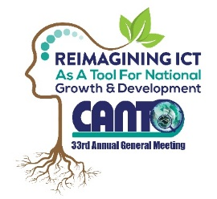 | 33rd Annual General Meeting  29^{th –} 31st January, 2017  Renaissance Hotel  Curacao

Technology Committee Meeting Agenda
Monday, 30th January 2017
Time: 1:00 pm – 2:30 pm

Chaired by: Shurmel Elias
Vice Chair: Lars Moltsen

Agenda
- Opening

- Approval of Draft Agenda

- Status of Internet of Things White Paper

- Status of Fibre TTH vs Wireless Paper

- CANTO 2017 – posible topics and speakers for event

- Action Plan for 2017

- Any other Business

- Next Meeting

- Closing

