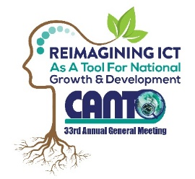 | 33rd Annual General Meeting  29^{th –} 31st January, 2017  Renaissance Hotel  Curacao

Vendor/Supplier Committee Meeting Agenda
Monday, 30th January 2017
Time: 1:00 pm – 2:30 pm

Chaired by: Bill Brown
Vice Chair: Lucretia Williams

Agenda:

- Opening

- Approval of Draft Agenda

- Status of “Preferred Supplier/Member” Section on CANTO’s website

- Initiate discussion on database of Vendors/Suppliers Clients in the region

- Initiate Vendor/Supplier & CANTO Workshop

- Action Plan for 2017

- Any other Business

- Next Meeting

- Closing

