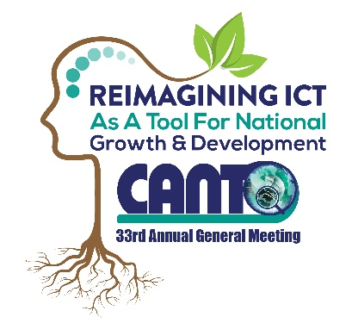 | CANTO’s 33rd Annual General Meeting  29th - 31st January, 2017  Renaissance Curacao  Co-hosted by: Bureau of Telecommunication & Post  And  United Telecommunication Services – Curacao  LIST OF DOCUMENTS | 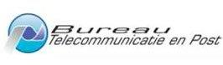

DOCUMENT No. | DESCRIPTION | LINK
Doc. 1. | 33rd AGM Notice
Doc. 2. | 33rd^{d} AGM Agenda
Doc. 3. | Minutes of 32 Annual General Meeting : 31st January – 2nd February 2016
Doc. 4. | Proxy Form
Doc. 5 | Amendments to the By Laws of CANTO
Doc.6. | Instructions to Participants
Doc. 7. | 2017 AGM Evaluation Form
Doc. 8. | 2017 Theme: “Reimagining ICT as a Tool for National Growth & Development”
Doc. 9. | Regulations Committee Meeting Agenda and Report
Doc. 10. | Marketing & Communications Committee Meeting Agenda and Report
Doc. 11. | Disaster Risk Management Committee Meeting Agenda and Report
Doc. 12. | Human Resource Committee Meeting Agenda and Report
Doc. 13 | Corporate Social Responsibility Committee Meeting Agenda and Report
Doc .14 | Vendor/Supplier Committee Meeting
Doc. 15 | Technology Trends Committee Meeting
Doc. 16 | Financial Advisory Committee Meeting Agenda and Report
Doc. 17. | CANTO Annual Report 2016
Doc. 18. | 2017 Calendar of Events Flyer
Doc. 19. | Information Document : CANTO Board of Directors Term in Office as at January, 2017

