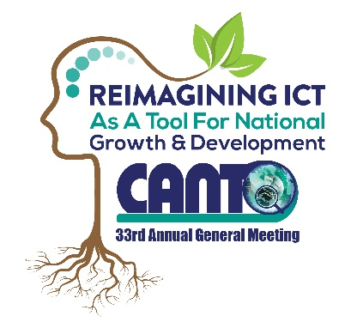

REGULATIONS COMMITTEE MEETING
MONDAY 30TH JANUARY, 2017

AGENDA
Time: 2.30pm

- Opening Remarks
- Approval of the Agenda
- Update on Activities for 2016
- Net Neutrality
- Universal Service
- Cyber Security
4) Country Update

5) Work Plan for 2017 (Limited to 3 items)
6) Closing Remarks

